Excel Homework - KickStart My Chart
Given the provided data, what are three conclusions we can draw about Kickstarter campaigns?
- By creating the pivot table and stacked column pivot chart, we counted how many campaigns were successful, failed, canceled, or are currently live per category, and filtered the data by country. From the figures below, we see that Kickstarter are more likely to be successful than to be failed or to be cancelled. Also, we found that the category of music had the highest success rate (77.14%), and the journalism had the lowest success rate(0%).

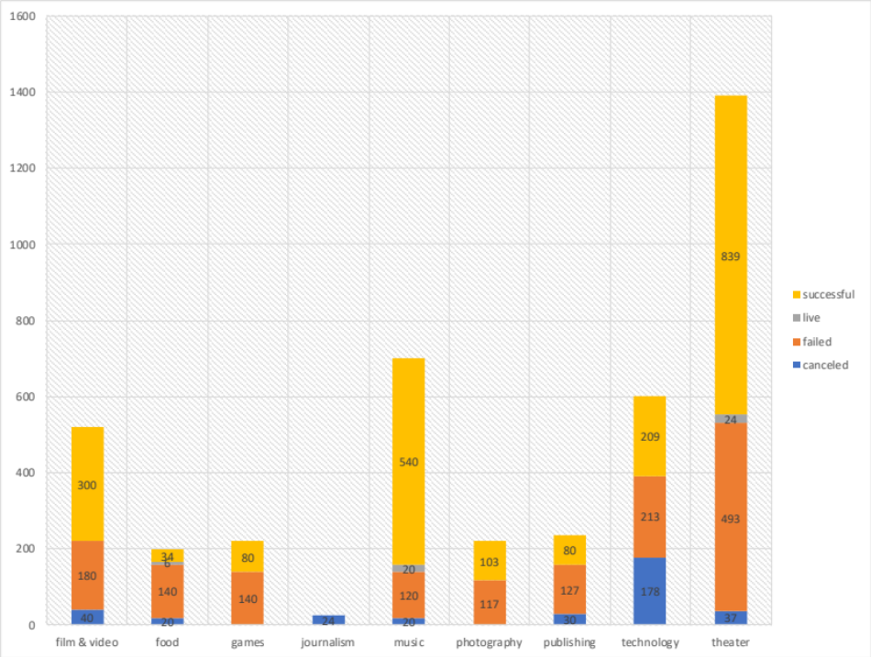
Figure 1
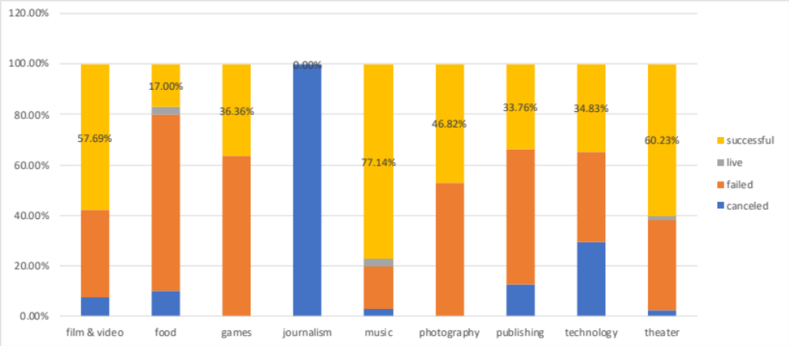
Figure 2
2. Then we also created a pivot table and stacked column pivot chart to see the relationship between sub-category and the outcomes of successful, failed, canceled and currently live. As shown in the figure 3, we can see that Many sub-category had 100% success rate, such as Music had Rock, Classical Music, Eletronic Music, Hardware, Metal, Documentary, Table top games, Television, etc. And Rock(260), Documentary(180), Hardware(140) had the most three highest number of projects.

Figure 3

- Then we create a pivot table and pivot chart line graph to see the relationship between outcomes and the time (Month). From the figure 4, we can conclude that the projects in first 6 months are more likely to succeed that those in later 6 months within a year. And in May, the success rate of project is the highest and in December, the success rate is the lowest.

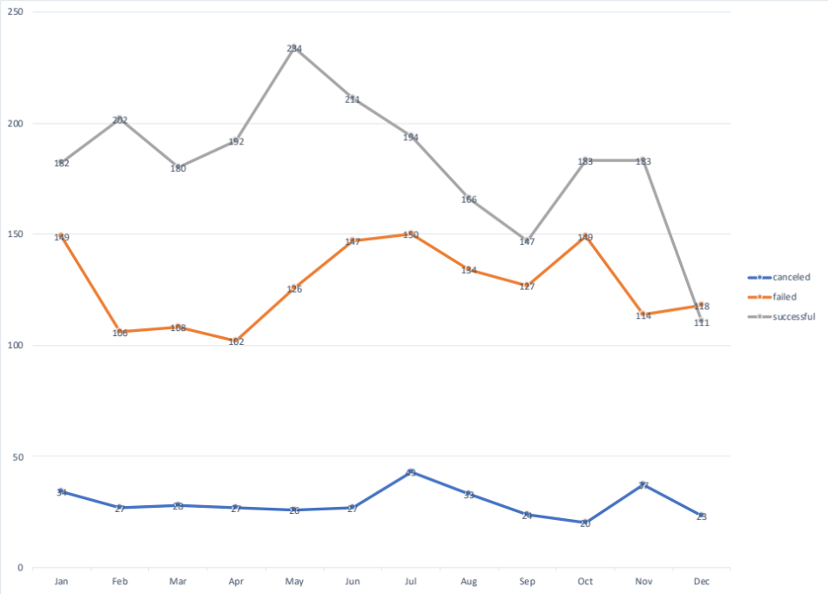
Figure 4

What are some limitations of this dataset?
I think the limitation of this dataset is that it is not large enough. It only has a small sample size of 4000+ project but actually Kickstarter has more than 300,000 projects launched. So, it may not accurately represent the data.
Also, I think there are many factors may influence the success rate of the projects.
What are some other possible tables and/or graph that we could create?
- Average donation.
- The information of backer.
- Geography analysis. Maybe we can see which state or area has the highest success rate.
- The duration of the projects. We can see the duration of successful projects and unsuccessful projects.

